**Experiment 2: Creating HTML forms using different form elements.**

1. Create a login page using different form elements.

Index.html

1. <!DOCTYPE html>
2. <html lang="en">
3. <head>
4. <meta charset="UTF-8">
5. <meta name="viewport" content="width=device-width, initial-scale=1.0">
6. <title>Login Page</title>
7. <style>
8. body {
9. font-family: Arial, sans-serif;
10. background-color: #f4f4f4;
11. }
12. .login-box {
13. max-width: 80vh;
14. margin: 50px auto;
15. background-color: #fff;
16. padding: 20px;
17. border-radius: 8px;
18. box-shadow: 0 0 10px rgba(0, 0, 0, 0.1);
19. }
20. table {
21. width: 100%;
22. }
23. table, td {
24. border: none;
25. }
26. td {
27. padding: 10px;
28. text-align: left;
29. }
30. input{
31. width: 50vh;
32. padding: 8px;
33. margin: 5px 0;
34. border: 1px solid #ccc;
35. box-sizing: border-box;
36. }
37. input[type="submit"]{
38. width: 500px;
39. background-color: #4caf50;
40. color: white;
41. cursor: pointer;
42. }
43. input[type="submit"]:hover {

      background-color: #45a049;

    }

1. </style>
2. </head>
3. <body>
4. <div class="login-box">
5. <h2>Login</h2>
6. <form>
7. <table>
8. <tr>
9. <td>Username:</td>
10. <td><input type="text" name="username" required></td>
11. </tr>
12. <tr>
13. <td>Password:</td>
14. <td><input type="password" name="password" required></td>
15. </tr>
16. <tr align="center">
17. <td colspan="2"><input type="submit" id="aa" value="Login"></td>
18. </tr>
19. </table>
20. </form>
21. </div>
22. </body>
23. </html>

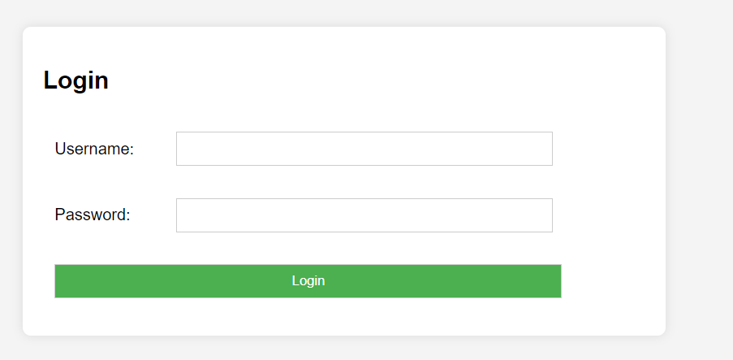

1. Create a HTML form for a student for course registration which should have following fields:
2. Student Name (textbox)
3. Age (textbox with numbers only)
4. Date of Birth (Calendar)
5. Select Course (Drop Down)
6. Submit (Button)

**Index.html**

<!DOCTYPE html>

<html lang="en">

  <head>

    <meta charset="UTF-8" />

    <meta name="viewport" content="width=device-width, initial-scale=1.0" />

    <title>Document</title>

    <link rel="stylesheet" href="index.css" />

  </head>

  <body>

    <div class="out">

      Registration Form

      <div class="in">

        <label for="studentName">Name</label>

        <input type="text" value="Student Name" />

        <label for="age">Age</label>

        <input type="number" value="Age" />

        <label for="dob">Date of Birth</label>

        <input type="date" value="Date of Birth" />

        <label for="course">Select Course</label>

        <select required>

          <option value="math">Math</option>

          <option value="science">Science</option>

          <option value="history">History</option>

        </select>

        <label for="email">Email ID</label>

        <input type="email" value="email" />

        <label for="phoneNumber">Phone Number</label>

        <input type = "text"  minlength="10" maxlength="12">

        <label for="password">Password</label>

        <input type="password" placeholder="password" required />

        <input type="submit" value="Register" />

        <input type="reset" value="Reset" />

      </div>

    </div>

  </body>

</html>

**Style.css**

body {

  background-color: rgb(54, 53, 53);

  display: flex;

  width: 100%;

  height: 100vh;

  align-items: center;

  justify-content: center;

  color: #e7e0d4;

  font-size: 1.5rem;

}

.out {

  text-align: center;

  padding: 20px;

  width: 100%;

  max-width: 400px;

border: 2px solid white;

}

.in input{

    width: 85%;

    padding: 10px;

    margin: 10px;

    border: 2px solid grey;

}

.in select{

    width: 90%;

    padding: 10px;

    margin: 10px;

    border: 2px solid grey;

}

.in input[type="submit"], .in input[type="reset"] {

    width: 100%;

    padding: 10px;

    background: #4caf50;

    color: white;

    cursor: pointer;

    border: none;

    border-radius: 4px;

  }

  .in input[type="reset"] {

    background: #f44336;}

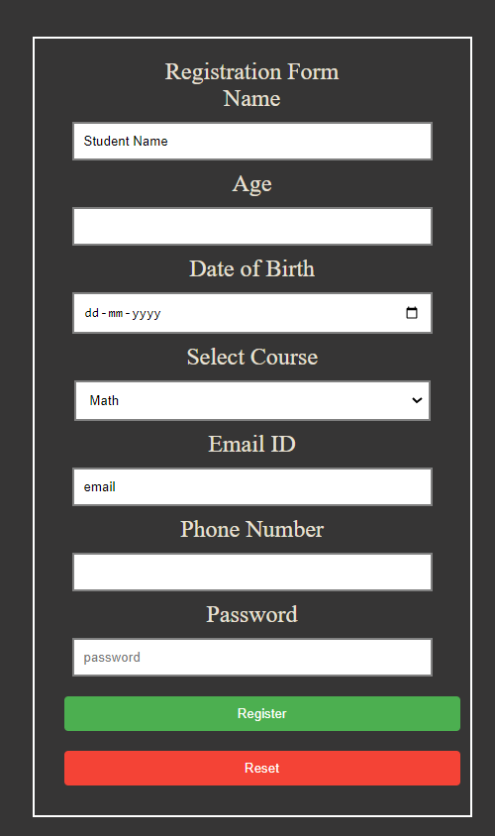

1. Create HTML form for selecting sports in your university. The form should have fields like Name, Password, Address, Select Game, Gender, Age etc.

<!DOCTYPE html>

<html lang="en">

<head>

    <meta charset="UTF-8">

    <meta name="viewport" content="width=device-width, initial-scale=1.0">

    <title>Sports Selection Form</title>

    <link rel="stylesheet" href="style.css">

</head>

<body>

    <div class="out">Sports Selection Form

        <div class="in">

            <label for="name">Name</label>

            <input type="text" id="name" name="name" placeholder="Student Name" required>

            <label for="pwd">Password</label>

            <input type="password" id="pwd" name="pwd" placeholder="Password" required>

            <label for="address">Address</label>

            <input type="text" id="address" name="address" placeholder="Address" required>

            <label for="game">Select Game</label>

            <select id="game" name="game" required>

                <option value="football">Football</option>

                <option value="basketball">Basketball</option>

                <option value="tennis">Tennis</option>

            </select>

<!--

            <label for="gender">Gender</label>

            <input type="radio" id="male" name="gender" value="male" required>

            <p>Male</p>

            <input type="radio" id="female" name="gender" value="female" required>

            <p>Female</p>  -->

            <div class="gender" style="margin: 10px 0;">

                <label>Gender</label>

                <div class="radio-group" style="display: flex; justify-content: space-between;">

                    <input type="radio" id="male" name="gender" value="male" required style="margin-right: 2px;">

                    <label for="male"  style="margin-right: 1px;">Male</label>

                    <input type="radio" id="female" name="gender" value="female" required style="margin-left: 2px;">

                    <label for="female"  style="margin-left: 1x;">Female</label>

                </div>

            </div>

            <label for="age">Age</label>

            <input type="number" id="age" name="age" placeholder="Age" required>

            <input type="submit" value="Register">

            <input type="reset" value="Reset">

        </div>

    </div>

</body>

</html>

body {

    background-color: rgb(54, 53, 53);

    display: flex;

    width: 100%;

    height: 100vh;

    align-items: center;

    justify-content: center;

    color: #e7e0d4;

    font-size: 1.2rem;

  }

  .out {

    margin: 20rem;

    text-align: center;

    padding: 20px;

    width: 100%;

    max-width: 400px;

    border: 2px solid white;

  }

  .in label {

    display: block;

    margin-bottom: 8px;

  }

  .in input, .in select {

    width: 100%;

    padding: 10px;

    margin: 10px 0;

    box-sizing: border-box;

    border: 2px solid grey;

    border-radius: 4px;

  }

  .in input[type="submit"], .in input[type="reset"] {

    width: 100%;

    padding: 10px;

    background: #4caf50;

    color: white;

    cursor: pointer;

    border: none;

    border-radius: 4px;

  }

  .in input[type="reset"] {

    background: #f44336;

  }

––––––––––